Vegetable Dyed Easter Eggs

Courtesy: Kim Foren, Geranium Lake Flowers

We thought we’d show you how to use veggies to dye your own eggs. PS. This super easy, fun project is also eco-friendly and non-toxic!
What you’ll need:
- Eggs (not boiled!)
- Vegetable skins: yellow or purple onions, beets, beet greens, tea bags and or tumeric
- Leaves and/or herbs (we like cilantro, parsley, bamboo, geranium, Japanese maple, cilantro, and dill)
- Old pantyhose (aka “tights”)
- 8 quart stock pot
- 3 tbsp vinegar
- Vegetable oil (optional)
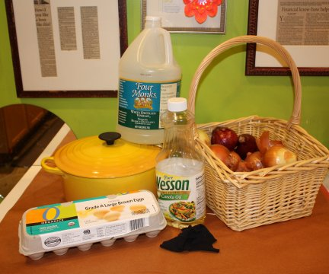
assemble your materials
Step 1: Bring to a boil water and 3 tbsp of vinegar. Add 2-4 cups of tightly packed veggie skins. Simmer for 15 minutes until the water has a gorgeous chestnut color (you can also add the tumeric and tea bags for extra color).
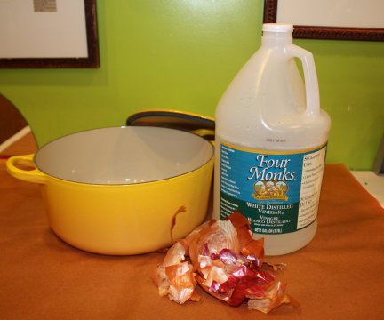
Step 2: Use scissors to cut pantyhose into several smaller sections. Each should be just large enough to stretch tightly around 1 egg.
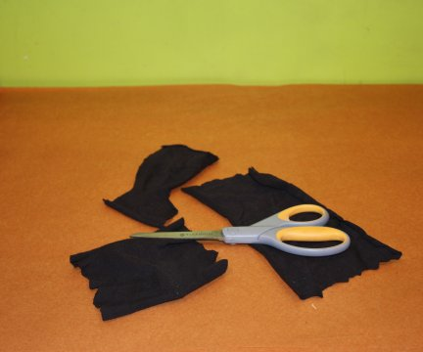
Step 3: Grab your herbs and leaves and start wrapping these textures around an egg (this will be the print that is left!) and gently wrap the egg in a piece of the cut pantyhose.

Step 4: Tightly tie off the end of the pouch (we like to use tiny zip ties).
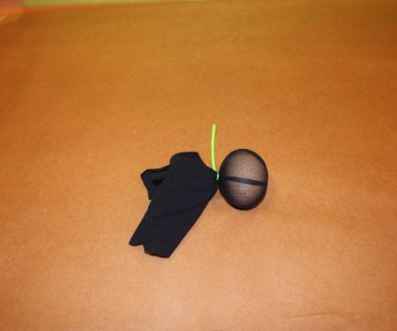
Step 4: Once you have a batch ready (about 12) drop each gently into your boiling veggie water! Boil for 10 minutes.
Step 5: At 10 minutes, turn the burner off and continue to let the eggs cool in the water for an additional 10 minutes. This gives them time to really soak up the dye!
Step 6: Use a spoon or soup ladle to scoop out each egg.
Step 7: Unwrap (you might have to use scissors to cut off the pantyhose) and peel off the leaves/herbs…
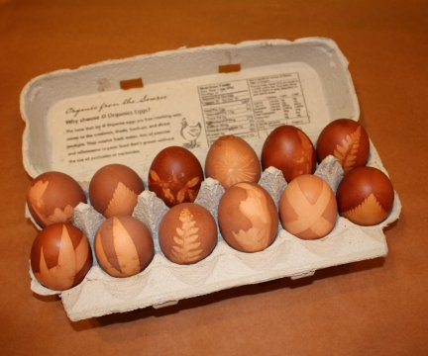
Step 8: Optional – to really make your eggs beautiful and delicate looking, rub each with a tiny drop of vegetable oil. It’ll make ‘em really shine!
Voila! Gorgeous, natural, non-toxic eggs!
And they’re edible (don’t worry – they won’t take on any of the onion flavor – we tested them!)

